Jefferson County Behavioral Health Services Directory

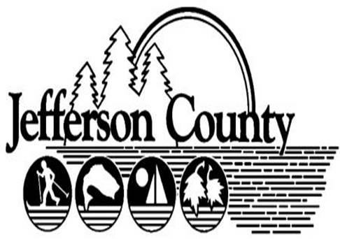

Jefferson County
Alcohol, Substance Abuse and Addiction Services

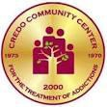Credo Community Center Treatment of Addictions
595 West Main Street (outpatient)
Watertown, NY 13601 Website: www.credocommunitycenter.com (315) 788-1530 / Fax: (315) 788-3794

Outpatient: Monday-Thursday 8am-7pm, Friday 8am-5pm Services Provided:
- Outpatient Substance Abuse
  - Individual treatment
  - Group Counseling
  - Individual counseling program
  - Specialized adolescent program
- Women’s Residential
  - 1130 State Street Watertown, NY
  - (315) 779-1772 / Monday-Friday 8am-4pm
  - 16 and up with a diagnosis of alcohol/ chemical dependency
  - Individualized programs for recovery, life skills education, relapse prevention education
- The Farm – RRSY
  - Evans Mills, NY (888) 585-2228
  - Total rehabilitative environment and program on 115-acre farm. 40+ hours treatment a week.
- Men’s Residential (2 Locations)- Community Residences
  - Winthrop Street & Washington Street Watertown, NY
  - Clean, safe, structured environment in a substance free home
  - Individualized programs of recovery
  - Life skills education
  - 6-12 month normal stay Insurances Accepted:
- Private, Self Pay, Medicaid, Sliding Scale, Tricare

1

The Metro Jefferson Drug Task Force
(315) 785-9555
jgolden@co.jefferson.ny.us

The Metro-Jefferson Drug Task Force is comprised of detectives from the Jefferson County Sheriff's Office, the Watertown Police Department, and the Jefferson County District Attorney's Office. The Task Force works closely with the New York State Police Central Narcotics Enforcement Team, the Jefferson County Probation Department, New York State Parole, the Drug Enforcement Administration of the United States Department of Justice and all local police agencies.

The Metro-Jefferson Drug Task Force is dedicated to making a difference in our community by pro-actively fighting against illegal narcotic trafficking and substance abuse.
The Task Force will remain diligent in the pursuit and apprehension of those individuals responsible for the import, distribution, and sales of narcotics and other substances in Jefferson County.

2 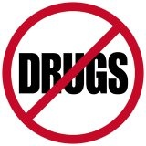

Jefferson County Drug Court
163 Arsenal Street
Watertown, NY 13601
(315) 785-3052

Monday-Friday 9am-5pm

Services Provided:
- Specialty court that provides intensive supervision and treatment as an alternative to incarceration for non-violent drug addicted offenders.

3

PIVOT -Alcohol and Substance Abuse Services
167 Polk Street Suite 320
Watertown, NY 13601
(315) 788-4660 / Fax (315) 788-4922
Website: www.pivot2health.com

Services Provided:
- New York State Drinking Driver Program (DDP)
- Community Coalitions, Alliance for Better Communities
- Employee Assistance Programs (EAPs)
- Problem gambling prevention
- Local and Regional Meetings
- School health and prevention programming
  - Second Step
  - Life Skills
  - Bullying
o Teen Intervene o Project Success o SPORT
- Prevention counseling
- Short term motivational counseling
- Information and Referral Service

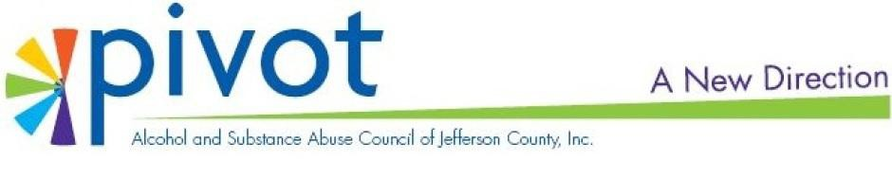

4

Samaritan Addiction Services 1575 Washington Street
Watertown, NY 13601
(315) 779-5074 / Fax: (315) 779-6678
Website: https://www.samaritanhealth.com/our- services/behavioral-health/addiction-services

Monday-Friday 8am-5pm

Services Provided:
- Individuals age 13 and up
- Brief treatment to intensive outpatient services
- Substance abuse education
- Alcohol and drug refusal training
- Cognitive Behavioral Therapy
- Relapse prevention
- Women’s and Men’s issue groups
- Stress management
- Integrated dual recovery group Insurances Accepted:
- Private, Self Pay, Medicaid, Tricare

5

Watertown Urban Mission
247 Factory Street
Watertown, NY 13601
(315) 782-8440 / Fax: (315) 782-8441
www.watertownurbanmission.com

(July1-August 31) Monday-Friday 8:30-12, 12:30-4
(September 1- June 30) Monday-Friday 8:30-12, 1-4:30

Services Provided:
- Bridge Program
  - Helps people who are faced with legal issues due to alcohol or drug abuse
  - Sentenced to Bridge Program by the courts
    - Treatment options
    - Case management
    - STOP DWI Victim Impact Panels

Fee:
- Panels are free to the public
- If mandated to attend then a $20 payment is required

6 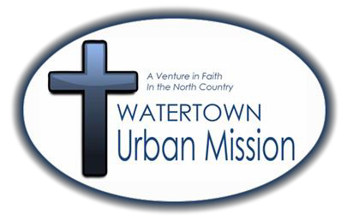

Jefferson County Mental Health Services

7

Carthage Area Hospital Behavioral Health
1001 West Street
Carthage, NY 13619 Website: www.carthageareahospital.com (315) 493-3300 / Fax: (315) 493-3306
Administrative Contact: (315) 493-3300 Monday-Friday 8am-6pm
Services Provided:
- Assist people with various emotional and mental health issues
- Referral required
- Licensed professional will conducted:
  - Adult & Child Services
  - Initial assessment and diagnosis
  - Verbal therapy
  - Medication therapy
  - Group therapy
  - Treatment planning
  - Play therapy
  - Clinical support
  - Health education Insurances Accepted:
- Medicaid, Medicare, Sliding Fee, Private, Self Pay, Tricare

8
Child and Adolescent Wellness Clinic
20104 NYS Rt. 3, Watertown NY 13601
(315) 779-7170

Monday- Friday 8am-4:30 pm

Services Provided:

- Provides Outpatient Psychiatric Services to children and adolescents
Age 5 to 17

- Insurances Accepted: Medicaid, Private Insurances, Sliding Scale, Self Pay, Tricare

9

Children’s Home of Jefferson County SPOA/SPOE
P.O. Box 6550 1740 State Street
Watertown, NY 13601
(315) 788-7430
Website: www.nnychildrenshome.com/single-point-of-access-for-
children-spoa/

Services Provided:
- Child
  - Responsible for managing Jefferson County Single Point Access (SPOA) process
    - Children and family are linked to services which best meet their needs
    - Specifically designed to serve 17 and under who are experiencing mental or behavioral difficulties
    - Referrals for services are sent to SPOA coordinator who then presents to SPOA committee
      - Community based service providers are identified and assigned to assist.
- Adult
  - Responsible for managing Jefferson County Single Point Entry (SPOE) process
    - Individuals are linked to services which best meet their needs
    - Designed to serve 18 years and up who are experiences mental or behavioral difficulties
    - Adult care management
    - Referrals for services are sent to SPOE coordinator who then presents to SPOE committee
      - 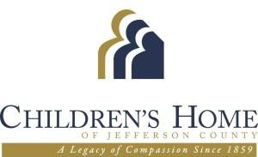Community based service providers are identified and assigned to assist

10

Community Clinic of Jefferson County
167 Polk Street Suite 300
Watertown, NY 13601
(315) 782-7445
Crisis Phone Number: (315) 782-2327 Website: www.nnychildrenshome.com/community-clinic/

Monday & Friday 8am-6pm, Tuesday & Thursday 7am-7pm, Wednesday 8am-8pm

Services Provided:
- Comprehensive treatment
  - Individual therapies
  - Couples/Family therapy
  - Group therapy
  - Psychopharmacologic treatment
  - Forensic evaluations and treatment
  - Neurofeedback
  - Psychological testing
- Recurring Treatment Groups
  - Anger management
  - Coping skills development
  - Stress management
  - Depression management
- Forensic Services
  - Tele psychiatry
  - Prevention services
  - Suicide assessment and interventions
  - Psychiatric counseling
  - Medical services
  - Rehabilitative services
  - Psychosocial and diagnostic assessment Insurances Accepted:
- Medicaid, Medicare, Private Insurances, Sliding Scale, Self Pay, Tricare

11

Credo Mental Health Clinic 595 West Main Street Watertown, NY 13601
(315) 788-1530 / Fax: (315) 755-2596
Website: www.credocommunitycenter.com

Monday-Thursday 8am-7pm, Friday 8am-5pm

Services Provided:
- Ages 16+
- Psychiatric diagnostic evaluation
- Psychiatric services
- Social work services
- Individual, family and group therapy
- Coping skills training
- Referral services
- Wellness promotion
- Care coordination services
- Medication monitoring
- Helping deal with:
  - Grief and loss
  - Low self esteem o History of abuse o Trauma
  - Depression
  - Anger management o Behavioral problems o ADHA
  - Life Crisis
  - Family Conflict
  - Chronic mental health problems Insurances Accepted:
- Private, Self Pay, Medicaid, Sliding Scale, Tricare

12

Family Counseling Service of Northern New York
120 Washington Street Suite 510
Watertown, NY 13601 Website: www.fcsnny.org
(315) 782-4483 / Fax: (315) 785-9210

Monday-Thursday 9am-7pm, Tuesday and Wednesday 9am-8pm, Friday 9am-2pm

Services Provided:
- Anger management
- Animal assisted therapy
- Domestic violence counseling
- Sexual abuse counseling
- Play therapy
- Parenting education
- Family counseling
- Couples and martial counseling
- Individual counseling
  - Emotional distress
  - PTDS
  - Anxiety
  - Grief
  - Depression Insurances Accepted:
- Private, Self Pay, Sliding Scale , Tricare

13

Fort Drum Behavioral Health Department
Building P36 Fort Drum, NY 13601 www.amedd.army.mil/clinics/bh.htm
(315) 772-2778
Monday-Friday 7:30am- 3:30pm Services Provided:
- Behavioral health counseling
- Individual and group medication management
- Tele-behavioral health services
- Alcohol and substance abuse treatment Insurance Accepted:
- No fee, for active duty members only

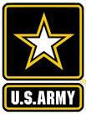14

Mental Health Association in Jefferson County
425 Washington Street
Watertown, NY 13601
(315) 788-0970 / Fax: (315) 788-8092
www.facebook.com/MHAJC.org

Days of Operation: Monday- Friday 8:30am-4pm Services Provided:
- Advocacy
  - Transportation to and support at health and wellness
- Vets peer to Peer center
  - 247 State Street
o (315) 681-6772 / Fax: (315) 221-4090
  - Monday, Wednesday, Friday 8:30am-4pm; Tuesday 12pm-7:30pm; Thursday 10am – 4pm
  - Drop in, non clinical, community based service that provides advocacy to all active duty members and vets
- Agape Project
  - Peer support for parents
  - Teaches life and parenting skills
  - Identifies appropriate resources geared toward keeping families together
- Bridges Program
- Various work units and educational areas to prepare for employment and recovery
Insurances Accepted:
- 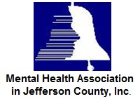No Fee

15

North Country Family Health Center
238 Arsenal Street
Watertown, NY 13601 Website: www.nocofamilyhealth.org (315) 782-6400 / Fax: (315) 782-1330

Monday-Friday 8am-4: 30pm, Friday 8am-4:30pm,

Services Provided:
- Individual, family and group therapy
- Psychological evaluations
- School based Health Centers
  - Watertown school district
  - South Jefferson school district Insurances Accepted:
- Private, Self Pay, Medicaid, Sliding Scale, Tricare, Child Health Plus

16

Northern Regional Center for Independent Living
210 Court Street Suite 107
Watertown, NY 13601 Website: http://nrcil.net/
(315) 785-8703 / Fax: (315) 785-8612
Monday-Friday 8:30am-4:30pm Services Provided:
- Advocacy
- Independent living program
- Family support services
- Parent training information center program
- Community connections programs
- Support groups Insurances Accepted:
- No fee

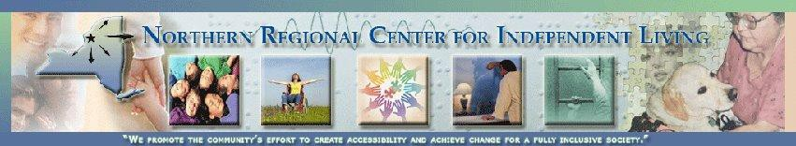

17

River Hospital Behavioral Health
3 James Street Alexandria Bay, NY 13607 Website: www.riverhospital.org
(315) 482-1277

Monday-Friday 8am-5pm

Services Provided:
- Intensive Outpatient Behavioral Health services for active duty members stationed at Fort Drum as well as the Mental Health needs of the local civilian community
- River Community Wellness Program (RCWP) Therapies Include:
  - Cognitive processing therapy o Group and individual therapy o Creative arts therapy
  - Movement therapy
  - Peer to peer therapy
  - Psychiatry and medication management Insurances Accepted:
- Private, Self Pay, Medicaid, Tricare

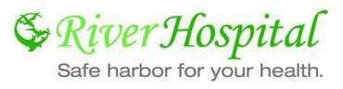
18

Samaritan Hospital Medical Center Inpatient
1575 Washington Street
Watertown, NY 13601
(315) 779-5060 / Fax: (315) 779-5028
Website: www.samaritanhealth.com

Services Provided:
- Evaluation
- Medication management
- Individualized treatment
- Groups
- Leisure time activities
- 32 beds- average stay 7-10 days Insurances Accepted:
- Private, Self Pay, Medicaid, Medicare, Tricare

19

Samaritan Outpatient Behavioral Health
1575 Washington Street
Watertown, NY 13601 Website: www.samaritanhealth.com (315) 779-5060 / Fax: (315) 779-5028
Monday- Thursday 8am-4:30pm, Friday 8am-5pm Services Provided:
- Outpatient psychiatry
- Traditional outpatient addiction services
- Psychopharmacology
- Diagnosis
- Evaluation Insurances Accepted:
- Private, Self Pay, Medicaid, Sliding Scale, Tricare

20

Transitional Living Services of Northern New York
482 Black River Parkway Watertown, NY 13601 Website: www.tlsnny.com
(315) 782-1777
Monday-Friday 8am-4: 30pm Services Provided:
- Treatment of both children and adults
- Medication management
- Counseling services
  - Group therapy
  - Couples counseling
  - Family therapy
  - Individual therapy
- Psycho educational sessions
- Supportive groups
- Adults
  - Health home case management
  - Supportive case management
  - Homeless case management
- Child
  - HCBS waiver services

Insurances Accepted:
- Private, Self Pay, Medicaid, Sliding Scale, Tricare

21

Private Providers

Beth Linderman – LCSW 125 Sherman Street
Watertown, NY 13601
(315) 785-5550

Deborah Schryver Counseling – M.S.
43223 New York 12 Alexandria Bay, NY 13607
(315) 686-6094

Diane Clark - LMHC 200 Washington Street Suite 205
Watertown, NY 13601
(315) 778-0742

Hope Counseling Services 205 Paddock Street
Watertown, NY 13601
(315) 788-9689
Hours: Monday-Friday 8am-6pm

Lucy’s House
120 Washington Street
Watertown, NY 13601
(315) 755-2665

22

Private Providers

Jeffery Aronowitz, MD 19332 US Route 11
Watertown, NY 13601
(315) 786-0190

Judith Pirro, LCSW 716 Washington Street
Watertown, NY 13601
(315) 408-5661

Lori Gooding- LCSW 117 Sherman Street
Watertown, NY 13601
(315) 405-2323

Ralph Marcellus- LCSW 24384 State Route 12
Watertown, NY 13601
(315) 788-3550

Rubenzahl and Knudsen Psychological Services
Thomas Knudsen- Psy.D. Samuel Rubenzahl- Ph.D. 22670 Summit Drive Suite 2
Watertown, NY 13601
(315) 788-3332
Hours: Monday-Friday 8am-6pm

Stephen Fitzgerald- Psychologist
18564 US Route 11
Watertown, NY 13601
(315) 785-8626

23

Private Providers

Toby Davis Psychological Services – Ph.D., MBA, CASAC
410 State Street
Carthage, NY 13619
(315) 942-9977

24

Jefferson County Children’s Services

25

Benchmark Family Services, Inc
1635 Ohio Street
Watertown, NY 13601
(315) 786-7285

Monday-Friday 7:30am-5pm

Services Provided:
- Early Learning Center
- Pediatric therapy and daycare Insurances Accepted:
- No Insurances Accepted, out of pocket expense

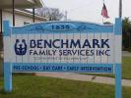
26

Children’s Home of Jefferson County
P.O. Box 6550 1704 State Street
Watertown, NY 13601 Website: www.nnychildrenshome.com (315) 788-7430 / Fax: (315) 785-5637
Monday-Friday 8:30am-4: 30pm Services Provided:
- Residential treatment center
- Therapeutic crisis respite program
- Non secure detention
- Foster care
- Community clinic
- SoZo teen center
- Visitation center
- Advantage after school
- Behavior to Health (B2H)
- Child intensive care management
- PINS prevention
- Article 10
- Post adoption Insurances Accepted:
- Private, Self Pay, Medicaid, Sliding Scale, Tricare, No Fee

27

Community Action Planning Council of Jefferson County
518 Davidson Street
Watertown, NY 13603 Website: www.capcjc.org
(315) 782-4900 / Fax: (315) 788-8251
Monday-Friday 8am-5pm Services Provided:
- Jefferson-Lewis childcare program
- Family center
- Head start and Pre K
- Housing and Energy Services
- Ready to Work Program Insurances Accepted:
- No Fee

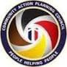28

Cornell Cooperative Extension of Jefferson County
203 North Hamilton Street Watertown, NY 13603
Email: Jefferson@cornell.edu Website: www.ccejefferson.org
(315) 788-8450 / Fax: (315) 788-8461
Monday-Friday 8:30am-4: 30pm Services Provided:
- Nontraditional education on youth and family development
- Parenting
- Nutrition
- Health community development
- Agriculture and horticulture Insurances Accepted:
- No Fee

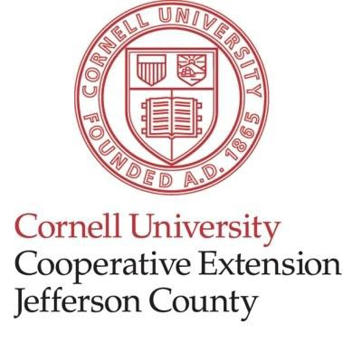29

Jefferson County Department of Social Services
250 Arsenal Street
Watertown, NY 13601 Website: www.co.jefferson.ny.us (315) 785-3133 / Fax: (315) 3346

Monday-Friday 9am-5pm Services Provided:
- Oversees children’s services
- Financial programs
- Prevention child protective services Insurances Accepted:
- No Fee

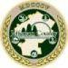
30

Northern Regional Center for Independent Living
210 Court Street Suite 107
Watertown, NY 13601 Website:http://nrcil.net
(315) 785-8703 / Fax: (315) 785-8612

Hours vary depending on the group please contact Northern Regional Center for Independent Living for further information.

Services Provided:
- When Anger Controls Kids
- Social Skills Learning Group
- Love and Logic parenting classes ($10 fee)
- Social Net

Insurances Accepted:
- No Fee

31

The House of Good Shepherd
26515 NYS Route 3
Watertown, NY 13601 Website: www.hgs-utica.com
(315) 782-8064 / Fax: (315) 782-8572

Monday-Friday 9am-5pm

Services Provided:
- Crisis respite
- Intensive treatment program
- The Milton Abe love Children’s Shelter
- Non-secure detention
- Foster care program
- Bridges to health
- Families forward
- Respite
- Quality improvement and training
- Therapeutic foster care
- Counseling
- Case management
- Family therapy
- Psychiatric and psychological consultation

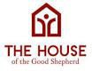

32

Transitional Living Services of Northern New York
482 Black Drive Parkway Watertown, NY 13601 Website: www.tlsnny.com
(315) 782-1777
Monday-Friday 8am-4: 30pm Services Provided:
- Advantage after school
- Children’s residential services
- Home and community based service waiver Insurances Accepted:
- Private, Medicaid, Medicare, Tricare

33

Jefferson County Disability Services

34

Acces-VR 333 East Washington Street Room 230
Syracuse, NY 13202
(315) 428-4179

Services Provided:
- Offers full array of services that may be needed by persons with disabilities through their lives
- Transitional and youth services
- Vocational rehabilitation
- Independent living services
- Business services
- Adult career and continuing education
- Vocational rehabilitation Insurances Accepted:
- No Fee

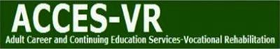
35

Association for the Blind and Visually Impaired of Jefferson County
321 Prospect Street
Watertown, NY 13601 Email: nanette@asnblindjeff.org Website: www.asnblindjeff.org
(315) 782-2451 / Fax: (315) 782-6890
Monday-Friday 8:30am-4pm Services Provided:
- In home visits
- Support groups
- Vision rehabilitation instruction
- Eye screenings
- Loan cupboard
- Adaptive aids
- Referrals and Information Insurances Accepted:
- No Fee

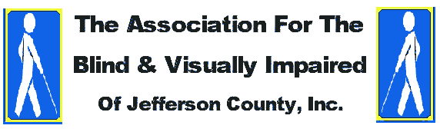
36335343

Cerebral Palsy Association of the North Country
167 Polk Street
Watertown, NY 13601 Website: www.cpnorthcountry.org
(315) 786-0983

Services Provided:
- Consumer Directed Personal Assistant Program
- Family Services
  - Medicaid service coordination
  - NYS Elks home service program
  - Family supportive case management
  - Reimbursement voucher subsidy
  - Development disabilities awareness program
- Community Living Opportunities
  - Individualized Residential Alternatives (IRA’s)
  - Individualized Supportive Services (ISS)
  - Outdoor recreation program
  - Hourly respite
  - Day habilitation
  - Community habilitation
  - Children’s accessible technology center
  - Assistive technology/ environmental modification Insurances Accepted:
- 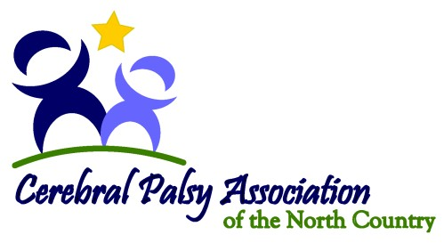Medicaid , Medicaid Managed Care Plans

37

Disabled Persons Action Organization
617 Davidson Street
Watertown, NY 13601 Email: dpa030@yahoo.com Website: www.dpao.org
(315) 782-5285 / Fax: (315) 782-6673

Monday-Friday 8am-4pm

Services Provided:
- Case Management/Medicaid Service Coordination/Plan of Care Support Services
- OPWDD Home/ Community Based Waiver Services
- Hourly Waiver Respite in home/ site based/ recreation/ youth summer recreation program
- Day habilitation certified site based or 1:1 in community
- Community habilitation 1:1 in home
- Supportive employment
  - Employment training program /Pathways to employment
- Autistic Recreation Program
- Free Standing Respite
- Assistive technology & environmental modifications
- Self Directed Services / Fiscal Intermediary
- Family Support Services
  - Family reimbursement/ voucher respite o Extracurricular activity reimbursement o Information, referral, and outreach
  - Parent support group
  - Workshops for individuals on residential waitlist
  - Snoozelin room/ behavioral management

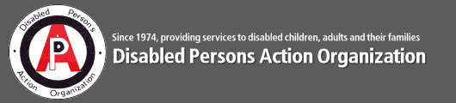Insurances Accepted:
- Medicaid

38

Hospice of Jefferson County 1398 Gotham Street
Watertown, NY 13603 Website: www.jeffhospice.org
(315) 788-7323 / Fax: (315) 788-9653

Monday-Friday 8am-4:30pm

Services Provided:
- Hospice care
- Family support
- Grief support
- Nursing home
- Residential care
- Palliative care
- Short term respite care (up to 5 days) Insurances Accepted:
- Private, Self Pay, Medicaid, Tricare

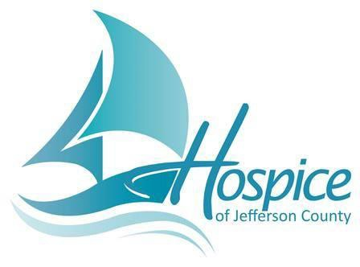39

Jefferson Rehabilitation Center
380 Gaffney Drive
Watertown, NY 13601 Website: www.thejrc.org Email: jrc@jeffrehabcenter.org
(315) 788-2730 / Fax: (315) 788-8557
Hours of Operation: Monday-Friday 8am-4:30pm Services Provided:
- Services developmentally disabilities or intellectual disabilities
- Residential Programs
  - Intermediate Care Facility (ICF)
  - Individual Residential Alternative (IRA)
  - Supported apartments
  - Respite services
  - Hourly waiver respite
  - Community habilitation
- Clinical Services
  - Physical therapy o Speech therapy o Recreation
  - Psychological and psychiatric services
  - Assistive technology
- Day programming
- Supported employment
- Case management
  - Medicaid service coordination o Plan of care supported services o Self directed services
- Vocational and community base pre-vocational
- Preschool early intervention program
- Preschool special education program
- 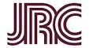Funded by government sources, Medicaid

40

Literacy of Northern New York 200 Washington Street
Watertown, NY 13601 Website: www.proliteracynny.org/
(315) 782-4270

Services Provided:
- Provided one on one tutoring to adults who are non readers to 8th grade level
- English classes
- Basic math skills
- Computer literacy
- Budgeting
- Citizenship Insurance Accepted:
- No Fee

41 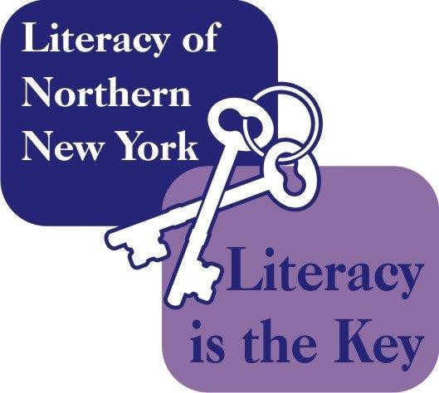

Jefferson County Emergency Services
& Housing Services

42

Catholic Charities 812 State Street
Watertown, NY 13601
(315) 788-4330 / Fax: (315) 786-0539
Monday- Friday 8:30am- 4: 30pm Services Provided:
- Individual, family counseling
- Administers TANF program
- Conducts maternity and parenting program
- Administers general catholic charities program

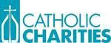

43

Monday-Friday 8am-5pm
Community Action Planning Council
518 Davidson Street
Watertown, NY 13601
(315) 782-4900

Services Provided:
- Head Start
- Universal Pre K
- Jefferson-Lewis Childcare Program
- Housing and energy services
- The Family Center Insurances Accepted:
- No Fee

44

Mental Health Association in Jefferson County
425 Washington Street
Watertown, NY 13601
(315) 788-0970 / Fax: (315) 788-8092

Services Provided:
- Drop In Center
  - Provides a network of peer support
  - Offers activities and social opportunities
  - Prevents members from being isolated
- Adult Respite
  - Provides short stay in studio apartment for temporary relief from a stressful situation in order to avoid hospitalization or a crisis
- HUD Homeless Housing Program
  - Incorporates temporary housing for the homeless with working to identify and overcome barriers to obtain permanent housing

45

Neighbors of Watertown 112 Franklin Street
Watertown, NY 13601 Website: www.neighborsofwatertown.com (315) 782-8497 / Fax: (315) 782-0102
Days of Operation: Monday-Friday 8am-5pm Services Provided:
- Community development organization
- First time homebuyer program
- County wide owner occupied home rehabilitation program
- Rental rehabilitation program
- Homebuyer Education Program
- Buy/Rehab/Resell
- Housing Rehabilitation Program
- Development
- Case Management

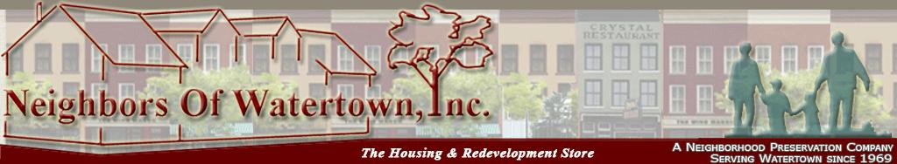

46

North Country Family Health Center
238 Arsenal Street
Watertown, NY 13601 www.nocofamilyhealth.org
(315) 782-6400 / Fax: (315) 782-1330

Monday-Friday 8am-4: 30pm

Services Provided:
- Health Care For All
  - Provides direct medical, dental and behavioral health services
  - Care coordination
  - Referral facilitation for individuals who are homeless or experiencing unstable and non permanent living situations
- Advocacy with Department of Social Services
- Referral for all Mental Health and Substance Abuse services Insurances Accepted:
- Private insurance, Tricare, Sliding Scale, Medicaid, Child Health Plus

47

Northern New York Cerebral Palsy Association
714 Washington Street
Watertown, NY 13601 Website: www.nnycerebralpalsy.org (315) 788-5650 / Fax: (315) 788-9186
Monday-Friday 8am-4pm Services Provided:
- Assistance, information/referrals and advocacy for a variety of developmental disabilities
  - Family support
  - Family reimbursement
  - Voucher respite reimbursement o Medicaid service coordination o Community habilitation
  - Day habilitation
  - Environment modifications / Assistive Technology
  - Family education and trainings
  - Support groups
  - Plan of care services
  - Front door trainings
  - Medical care specializing in orthopedic care Insurances Accepted:
- 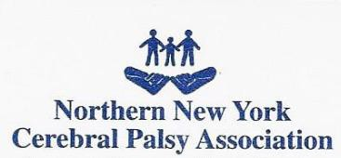Medicaid, Medicare, Private Insurance, Self Pay, Sliding Scale, Tricare

48

Northern Regional Center for Independent Living
210 Court Street Suite 107
Watertown, NY 13601 Website:http://nrcil.net
(31) 785-8703 / Fax: (315) 785-8612
Monday-Friday 8:30am-4: 30pm Services Provided:
- Independent living program
- Community connections programs
- Family support services
- Parent training information center program
- Educational classes and workshops
- Support groups

49

Transitional Living Services of Northern New York
482 Black Drive Parkway Watertown, NY 13601 Website: www.tlsnny.com
(315) 782-1777

Services Provided:
- Must have a mental health diagnosis
- Residential services
- Supported housing
- Health home case management
- Homeless case management Insurances Accepted:
- No Fee

50

Victims Assistance Center of Jefferson County
120 Arcade Street
Watertown, NY 13601 Website: www.vacjc.com
(315) 782-1823 / Fax: (315) 782-3760
Crisis Phone Number: (315) 782-1855
Monday-Friday 8am-4: 30pm Services Provided:
- 24 hour safe shelter
- Homeless housing
- Counseling
- Advocacy
- Immediate response team
- Community outreach
- Preventative training Insurance Accepted:
- 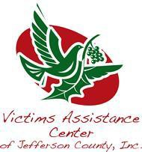No Fee

51

Watertown Urban Mission
247 Factory Street
Watertown, NY 13601
(315) 782-8440 / Fax: (315) 782-8441

(July1-August 31) Monday-Friday 8:30-12, 12:30-4
(September 1- June 30) Monday-Friday 8:30-12, 1-4:30

Services Provided:
- Critical needs
- Food pantry
- Hearth- rental assistance
- Impossible Dream Thrift Store
- Christian Care Center
- Meals on Wheels
- Food Sense Program

52

Respite Providers

Cerebral Palsy of the North Country
167 Polk Street
Watertown, NY 13601
(315) 786-0983

Children’s Home of Jefferson County
P.O. Box 6550 1704 State Street
Watertown, NY 13601
(315) 788-7430

Disabled Persons Action Organization
617 Davidson Street
Watertown, NY 13601
(315) 782- 5285

Hospice of Jefferson County 1398 Gotham Street
Watertown, NY 13603
(315) 788- 7323

Jefferson Rehabilitation Center
380 Gaffney Drive
Watertown, NY 13601
(315) 788-2730

The House of Good Shepard
26515 NYS Route 3
Watertown, NY 13601
(315) 782-8064

Transitional Living Service of Northern New York
482 Black River Parkway Watertown, NY 13601
(315) 782-1777

53

Table of Contents

Alcohol, Substance Abuse and Addiction Services ………… Page 2 Mental Health Services …………………………………………….. Page 8 Children’s Services …………………………………………………….. Page 25 Disability Services ……………………………………………………… Page 34 Emergency Services & Housing Services ………………………… Page 42

Jefferson County Community Services
175 Arsenal Street, Watertown NY 13601
(315) 785-3283

Updated 04/01/2016

